Regional Overview

Introduction
The subject is located in the Deep East Texas Workforce Development Area (WDA). The Deep East Texas WDA includes the following twelve counties: Angelina, Houston, Jasper, Nacogdoches, Newton, Polk, Sabine, San Augustine, San Jacinto, Shelby, Trinity, and Tyler.
The region is primarily rural in character and located in East Texas near the Louisiana border. Major population centers include Lufkin and Nacogdoches. The regional economy is supported by healthcare services, education, timber and forestry products, manufacturing, trade, and government-related employment.
The Deep East Texas WDA functions as a regional service hub for surrounding rural communities, supporting healthcare, retail trade, public administration, and light industrial activity.

Regional Map
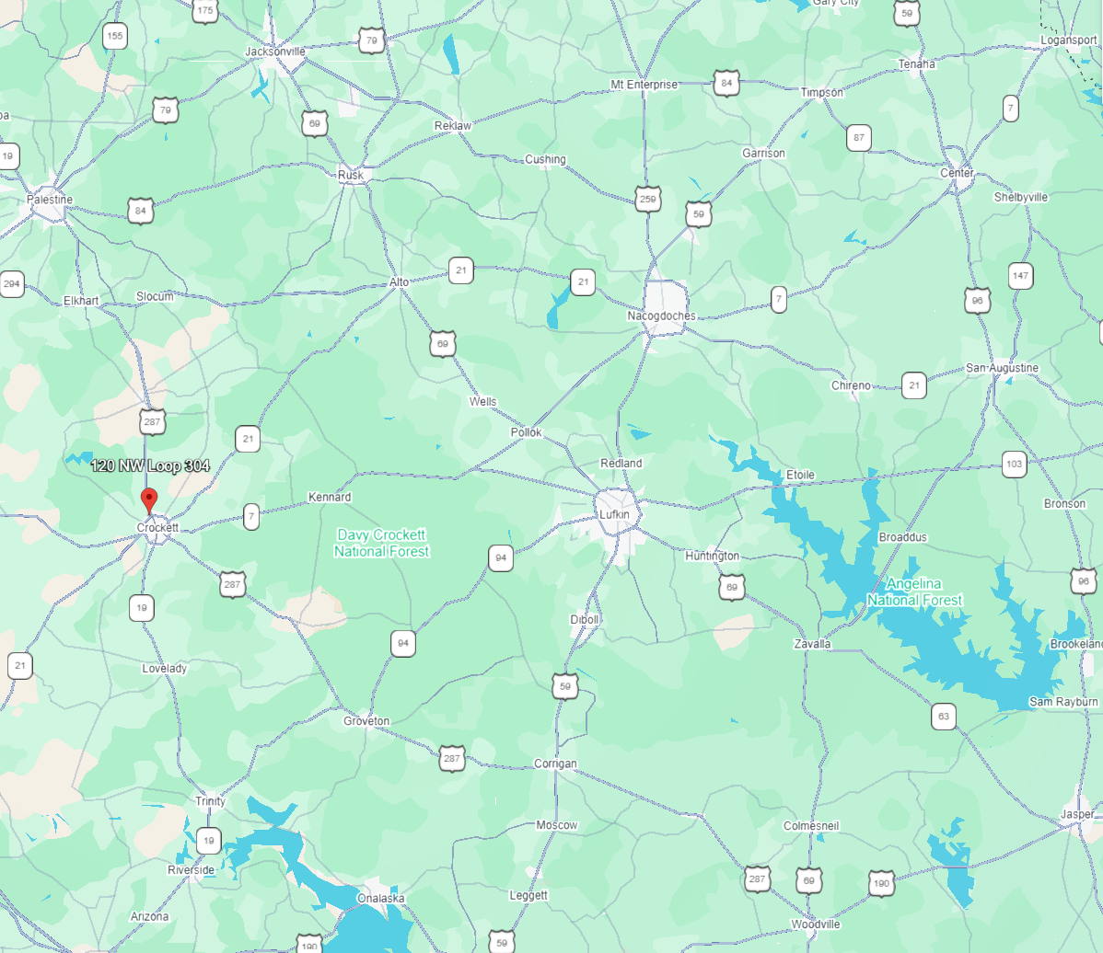
The following information is from Workforce Development Area Profiles – Deep East Texas, published by the Texas Workforce Commission (December 2025)
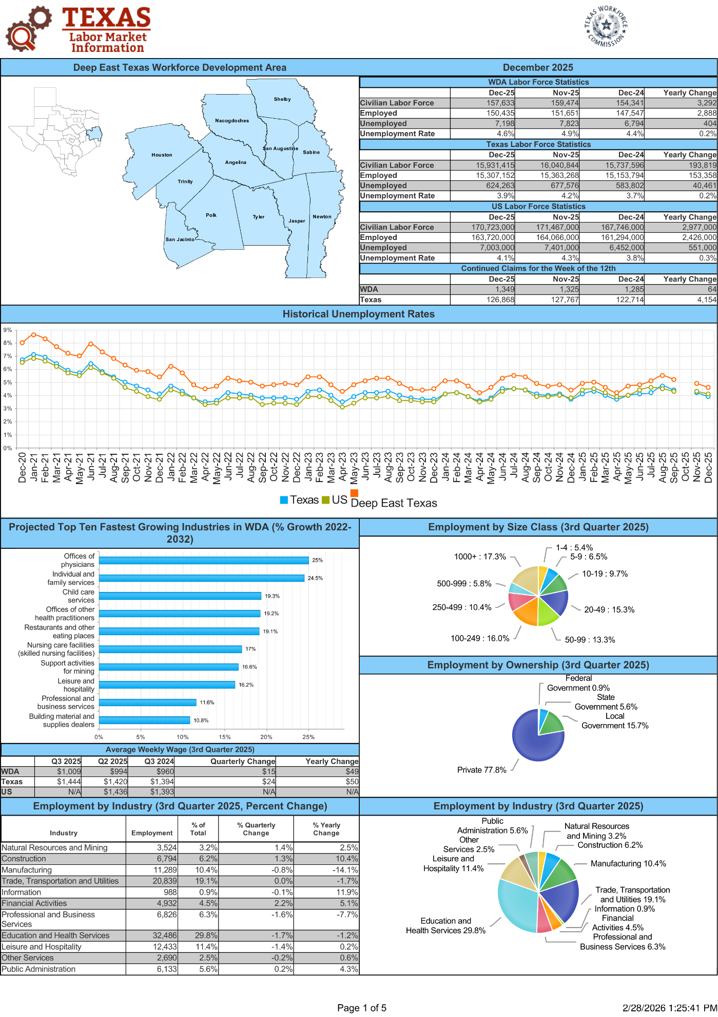
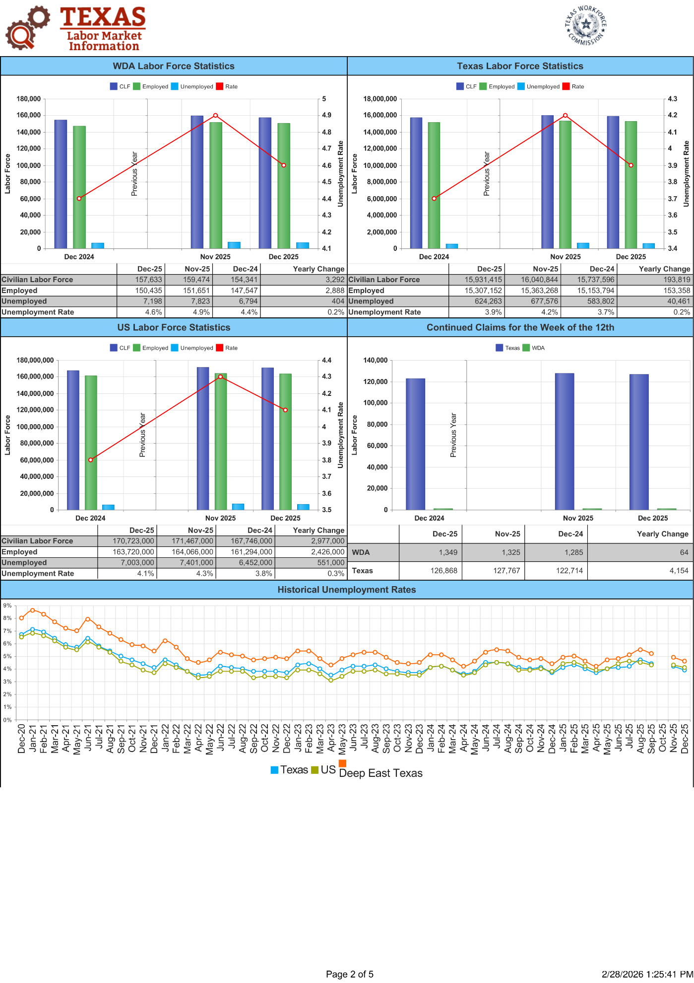
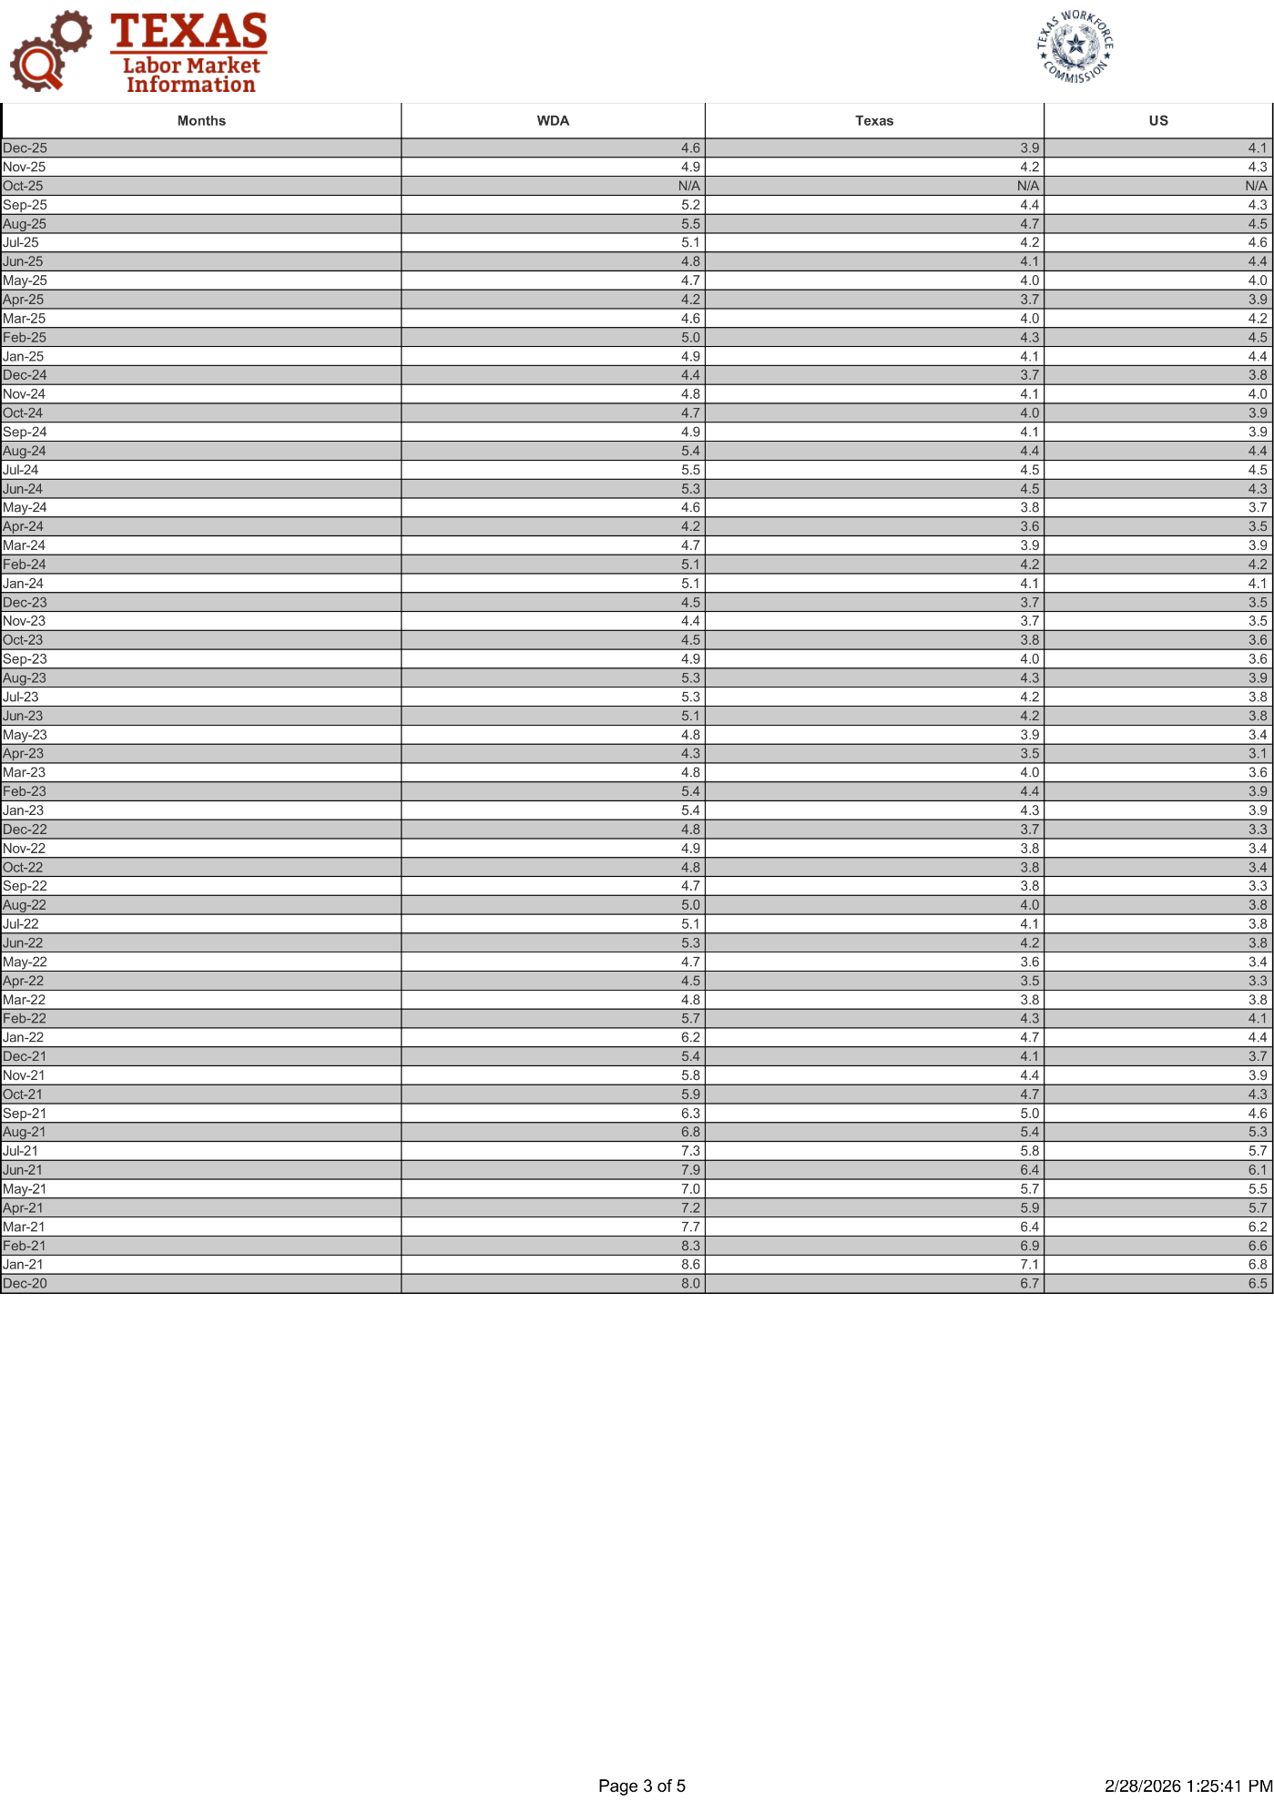
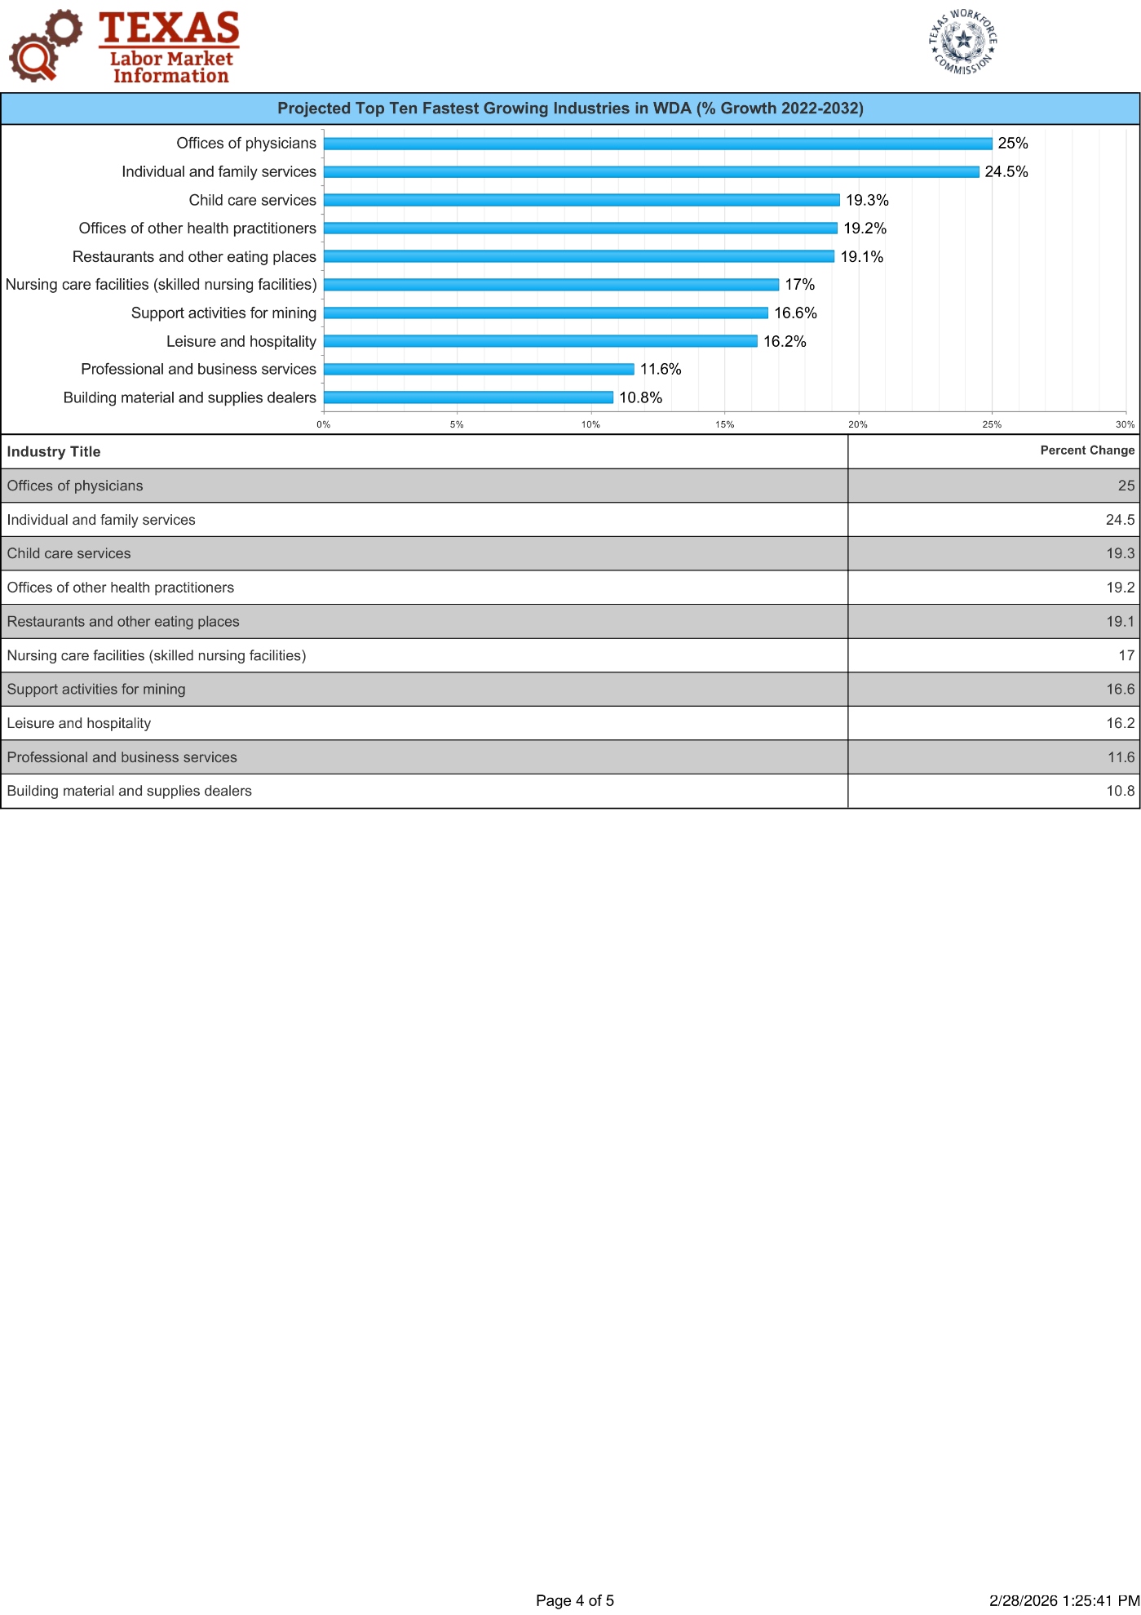
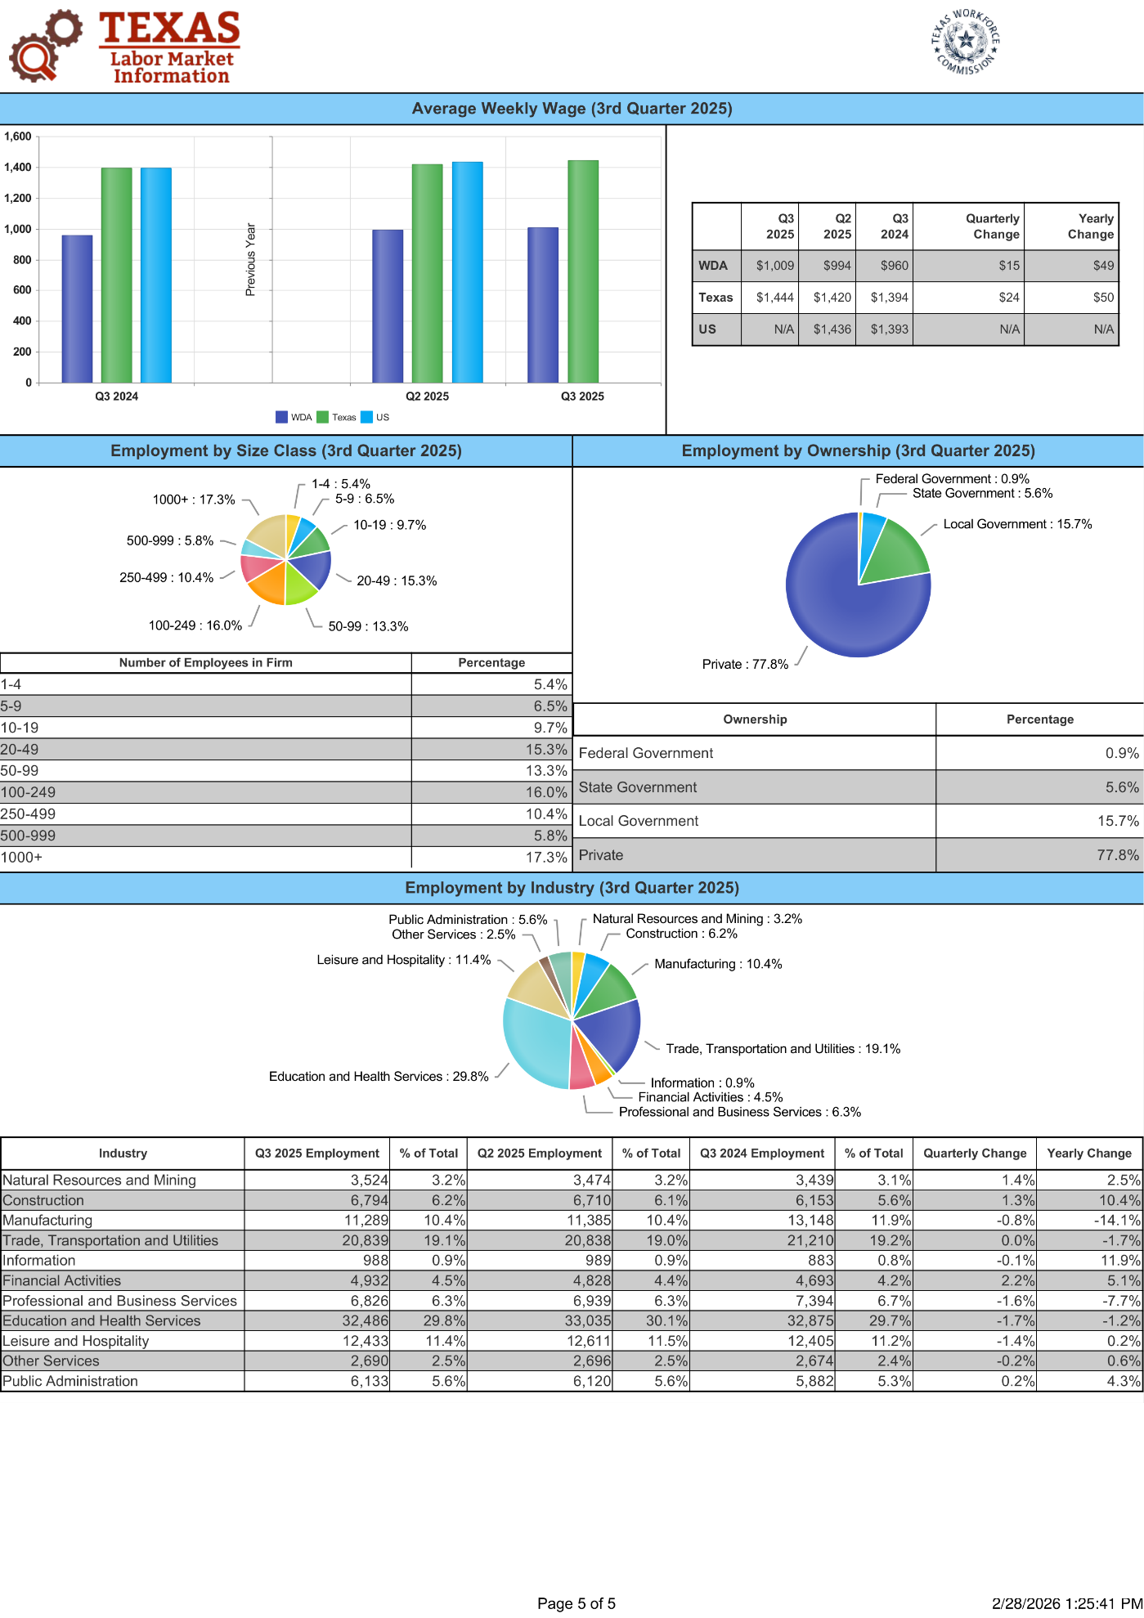

Labor Force
As of December 2025, the Deep East Texas WDA had:
• Civilian Labor Force: 157,633
• Employed: 150,435
• Unemployed: 7,198
• Unemployment Rate: 4.6%
The unemployment rate of 4.6% is above the Texas average of 3.9% and the national average of 4.1%, indicating a moderately higher level of labor market slack compared to the broader state and national economies.
The average weekly wage in Q3 2025 was $1,009, reflecting a $49 year-over-year increase and a $15 quarterly increase. While below the Texas average of $1,444, wage growth demonstrates gradual improvement and steady regional economic activity.
Industry Overview
The Deep East Texas WDA maintains a diversified but healthcare-oriented employment base. As of Q3 2025, the largest employment sectors included:
- Education and Health Services – 29.8%
- Trade, Transportation and Utilities – 19.1%
- Leisure and Hospitality – 11.4%
- Manufacturing – 10.4%
- Construction – 6.2%
- Professional and Business Services – 6.3%
- Public Administration – 5.6%
- Financial Activities – 4.5%
- Natural Resources and Mining – 3.2%
- Other Services – 2.5%
- Information – 0.9%

Education/Health Services and Trade/Transportation together account for approximately 48.9% of total employment, highlighting the region’s dependence on healthcare services, regional retail trade, and distribution activity serving local populations.
Manufacturing remains a meaningful component of the regional economy, though it experienced a year-over-year decline of 14.1%, reflecting ongoing structural shifts within certain industrial sectors.

Employment Trends and Projection
Between 2022 and 2032, the fastest-growing industries in the Deep East Texas WDA are projected to include:
- Offices of Physicians – 25.0%
- Individual and Family Services – 24.5%
- Child Care Services – 19.3%
- Offices of Other Health Practitioners – 19.2%
- Restaurants and Other Eating Places – 19.1%
- Nursing Care Facilities – 17.0%
- Support Activities for Mining – 16.6%
- Leisure and Hospitality – 16.2%
- Professional and Business Services – 11.6%
- Building Material and Supplies Dealers – 10.8%
Projected growth is heavily concentrated in healthcare-related services, reflecting demographic trends, aging populations, and regional demand for medical and personal care services.
Growth in leisure and hospitality, restaurants, and building material suppliers suggests continued incremental population stability and local economic activity rather than large-scale urban expansion.
Employment by Firm Size and Ownership
Employment within the Deep East Texas WDA is moderately distributed across firm sizes:
- 17.3% of jobs are in firms with 1,000+ employees
- 16.2% of jobs are in firms with 250-999 employees
- 16.0% are in firms with 100–249 employees
- 15.3% are in firms with 20–49 employees
- Smaller firms (1–9 employees) collectively account for approximately 21.6%

Private sector employment accounts for 77.8% of total jobs in the region, followed by::
- Local Government – 15.7%
- State Government – 5.6%
- Federal Government – 0.9%
Compared to more urban WDAs, the region shows a higher concentration of government employment, consistent with the role of public education, healthcare systems, and local administrative functions in rural economies.
Unemployment Trends

Historical data indicates that unemployment in the Deep East Texas WDA peaked during the COVID-19 pandemic in 2020 at approximately 8–9%, before steadily declining through 2021 and 2022.

From 2023 through 2025, unemployment has generally stabilized within the 4% to 5% range, with periodic seasonal fluctuations.

As of December 2025, unemployment stands at 4.6%, reflecting a stable but slightly softer labor market relative to statewide conditions.

Conclusion
The Deep East Texas Workforce Development Area represents a stable, healthcare-centered regional economy serving a largely rural population base. With a labor force of approximately 158,000 workers, moderate wage growth, and a diversified employment structure anchored by healthcare, trade, manufacturing, and public administration, the region demonstrates steady economic fundamentals.
Key strengths include healthcare services, regional retail trade, public-sector employment, and light manufacturing. Projected growth in physician offices, personal services, nursing care facilities, and hospitality-related industries reflects demographic demand rather than rapid metropolitan expansion.
While unemployment remains modestly above the Texas average and wage levels trail larger metropolitan areas, the Deep East Texas WDA shows continued resilience supported by essential services, healthcare infrastructure, and stable public-sector employment.

Market Area Analysis
A market area is the geographic area in which the subject property competes for the attentions of market participants; the term broadly defines an area containing diverse land uses. Market areas are defined by a combination of factors including physical features, and socioeconomic characteristics of the residents or tenants, the condition of the improvements and land use trends. Market area analysis focuses on the identification of boundaries and the social, economic, governmental and environmental influences that affect the value of real property within those boundaries.
The purpose of a market area analysis is to provide a bridge between the study of general influences on all property values and the analysis of a particular subject. Market area boundaries are identified by determining the area in which the four forces that affect value (social, economic, governmental and environmental) operate in the same way they affect the subject property. Interaction of the various components influencing these four forces often results in the dissimilarities regarding the length of time between the stages of a market area’s life cycle.

Market area Map
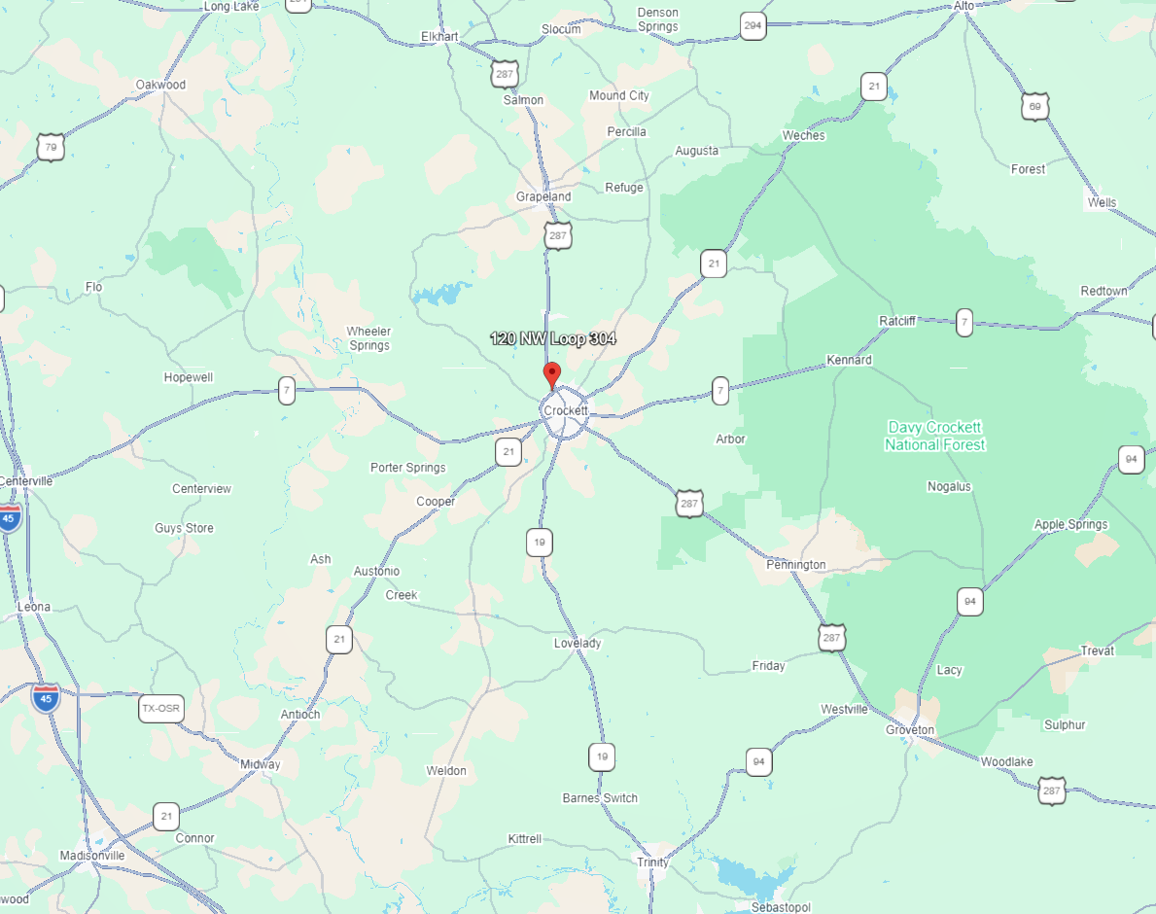

General Description
For this analysis, the market area is defined as Houston County, Texas. Houston County is located in East Texas approximately 140 miles north of Houston and approximately 120 miles southeast of Dallas. The county seat is Crockett, which serves as the primary governmental, commercial, and employment center of the county. Other communities in the county include Grapeland, Lovelady, Latexo, Kennard, and Ratcliff.
Houston County is characterized by a predominantly rural landscape consisting of agricultural land, timberland, scattered rural residential development, and small community centers. The county lies within the Piney Woods region of East Texas, and forestry and agriculture have historically played an important role in the local economy.
Commercial activity and public services are primarily concentrated in Crockett, where retail, healthcare, education, government services, and small-scale industrial uses support the local population. Outside the Crockett area, land use patterns consist largely of agricultural operations, timber production, ranching activities, and low-density residential properties.
Houston County functions as a rural service area supporting surrounding agricultural lands and smaller communities while maintaining connections to larger regional employment centers such as Lufkin, Palestine, and Huntsville.
Access And Major Roadways
Houston County is served by several regional highways that provide connectivity to surrounding employment centers and markets:
• U.S. Highway 287 – A major north-south route running through Crockett that connects the county to Corsicana and the Dallas region to the north and to Lufkin and Southeast Texas to the south.
• State Highway 19 – Provides north-south access through the county, connecting Palestine to the north and Huntsville to the south.
• State Highway 21 – An east-west corridor connecting Crockett with Madisonville and Bryan/College Station to the west and with Nacogdoches and East Texas markets to the east.
• Farm-to-Market Roads – Numerous FM roads and county-maintained roadways provide access to rural residential properties, agricultural operations, timberland tracts, and recreational lands throughout the county.
While Houston County does not have direct interstate access, the regional highway network provides adequate transportation connectivity for residents, agriculture, and local commerce. These roadways also support travel to larger employment centers and regional retail hubs in surrounding counties.
Land Use And Supportive Development
Houston County exhibits a rural land use pattern with development concentrated primarily in Crockett and smaller incorporated communities.
Residential
Residential development consists mainly of single-family homes within Crockett and smaller towns such as Grapeland and Lovelady. Rural residences located on acreage are common throughout the county. Housing density is generally low outside municipal areas, and development has occurred gradually over time rather than through large subdivision projects.
Commercial
Commercial development is concentrated within Crockett along major corridors such as Loop 304, State Highway 19, and U.S. Highway 287. Commercial uses include local retail stores, restaurants, service providers, financial institutions, medical offices, and small business establishments that serve both the local population and surrounding rural areas.
Industrial
Industrial development within Houston County is limited but includes light manufacturing, lumber-related operations, agricultural support services, and small distribution or fabrication facilities. Timber and forestry-related businesses remain an important component of the local economy.
Agricultural and Open Land
Agriculture and timber production represent significant land uses throughout Houston County. Activities include cattle ranching, poultry operations, hay production, and timber harvesting associated with the Piney Woods region. Large tracts of rural land are also utilized for recreational and hunting purposes.
Recreational and Institutional
Houston County includes public school districts, county government facilities, churches, healthcare providers, and community centers. Recreational resources include Davy Crockett National Forest, lakes, parks, and outdoor recreational areas that support hunting, fishing, and tourism activities.
Life Stage and Trends
The market area is considered to be in a stable rural stage with modest long-term growth characteristics. Houston County has experienced relatively steady population trends typical of rural East Texas counties.

Economic stability is supported by:
• Agriculture and timber industries
• Local government and education employment
• Healthcare services
• Small business and retail activity in Crockett
• Regional commuting to nearby employment centers

While Houston County does not experience rapid urban expansion, the area benefits from relatively affordable land values, a rural lifestyle appeal, and stable long-term land uses associated with agriculture and forestry.

Recent development patterns reflect gradual residential demand, particularly for rural homesites and small acreage tracts. Commercial development has been limited but consistent with the needs of the local population. Construction activity is generally market-driven and tends to occur near Crockett or along major highway corridors.

Existing improvements throughout the county are generally average in condition with some newer residential construction occurring sporadically in both town and rural settings.

Future development trends are expected to include:
• Continued rural residential development
• Ongoing agricultural and timber land use
• Limited commercial expansion in Crockett
• Recreational and rural land purchases

Overall growth is expected to remain modest and consistent with the county’s rural economic base.
Conclusion
Houston County provides a stable rural market environment characterized by agricultural and timber-based land uses, small community centers, and modest commercial activity concentrated in Crockett.

Key factors supporting the local market include:
- Regional highway connectivity
- Established agricultural and forestry industries
- Affordable land and housing costs
- Local government, healthcare, and education services
- Recreational resources including national forest lands

Although development intensity is lower than in metropolitan regions, Houston County demonstrates stable long-term land use patterns and steady demand for rural residential and agricultural properties. Future growth is expected to remain gradual and market-driven, with development largely focused around existing communities and transportation corridors.
Overall, Houston County represents a stable rural market area with consistent land use patterns and long-term viability supported by agriculture, forestry, and local service industries.

